It is widely thought that Hero of Alexandria, an Egyptian engineer born in the first century AD and considered to be one of the greatest inventors of ancient times, created the first Steam Engine. He also invented a coin operated Holy Water Dispenser, a primitive programmable robot – and an early diagram of a Fire Engine.

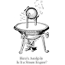 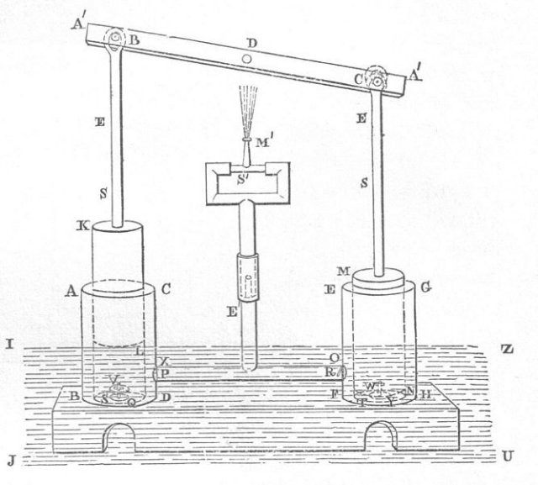

**Combustion Engine Fire Engine**

The point is – Alexandria, Egypt has always been a hot bed of engineering excellence and innovation. Flash forward a few eons and meet two modern day IBM Hero’s – both from Alexandria, Egypt – Nader and Tamer Nassar.

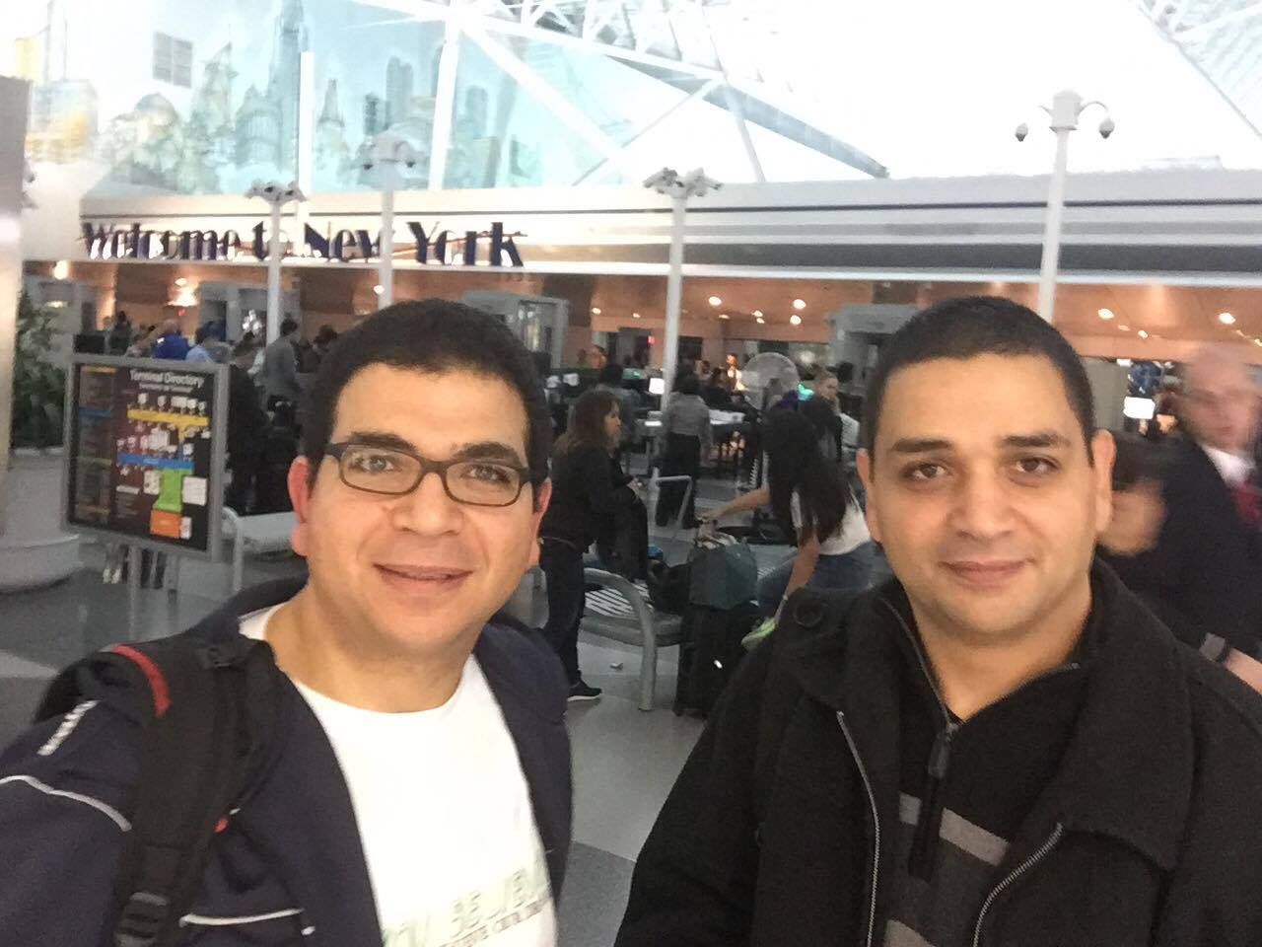

While Hero was known as the Father of Physics, Tamer and Nader grew up under the tutelage of a Father of Chemistry – their father Mohammed, who was a high school chemistry teacher in their native Egypt. Mrs. Nassar was a head nurse on a cardiology unit at Alexandria University Hospital.

“We showed an early aptitude for Math and Computers” said Tamer, “My parents always encouraged us. Dad used to explain the reason behind this or that, he challenged our minds to think and be inquisitive - and he was perfectionist – he instilled in us you have to be the top – that you always had to earn it.”

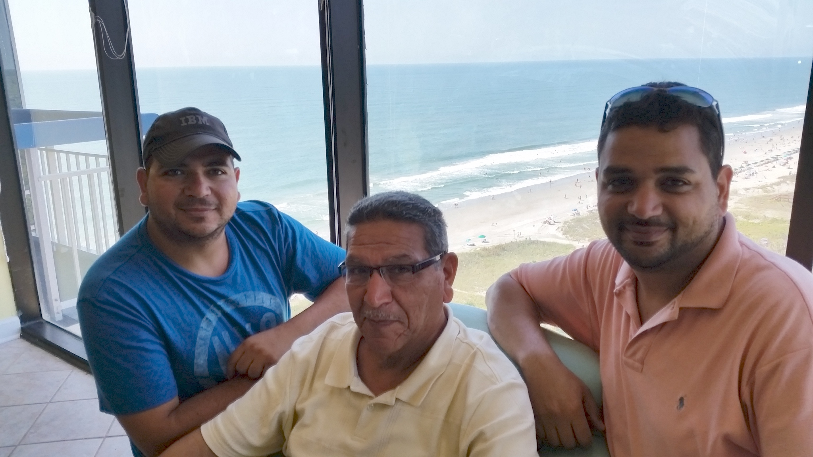

Says Nader, “we both decided to come to the United States to pursue our American dream. This was a huge sacrifice for my parents because we are their only children, and typically, boys don’t leave home until they marry. But they were happy for us because they saw us progressing and moving on the right path from Egypt to a better opportunity - even if it was 6000 miles from home”

Nader came first, getting his BS in Electrical Engineering from CCNY in New York.

He received a Master’s in Electrical Engineering and finally a PhD in Computer Science with a focus in Cybersecurity from Pace University. “During my senior year at CCNY IBM was doing campus recruitment – and I wound up with five offers that day. I began my IBM career as a Notes developer in GBS, then moved to Websphere working in Global Asset Recovery before moving to CIO where I’m a senior IT Architect in the identity service domain”. He also teaches programming and cybersecurity at both New York University and Pace University.

As for Tamer, he graduated from Alexandria University with a BS in Electrical Engineering, and followed his brother to CCNY (Nader paid his brother’s first year tuition from his IBM paycheck). While working on his Master’s degree he got a job as a research assistant working on wireless networking. With his Masters came a job offer from IBM, where he started as a software engineer working on the Kodak polychrome graphics account. “Working in GBS with Kodak and then Aetna really helped me put myself in the client’s shoes and taught me how to be responsive and manage expectations”.

From there he moved to the CIO organization as the team leader for the IBM Innovation Lab as the Technical Manager of CIO Cloud Services. Oh, he also finds time to be an Adjunct Professor, teaching a graduate level course in Database at both Western Connecticut State University and Marist University.

In between, they had time to marry, become American citizens, be named IBM Master Inventors, and father seven children (Nader has four, Tamer three). Oh, Tamer has 18 patents and Nader has 45.

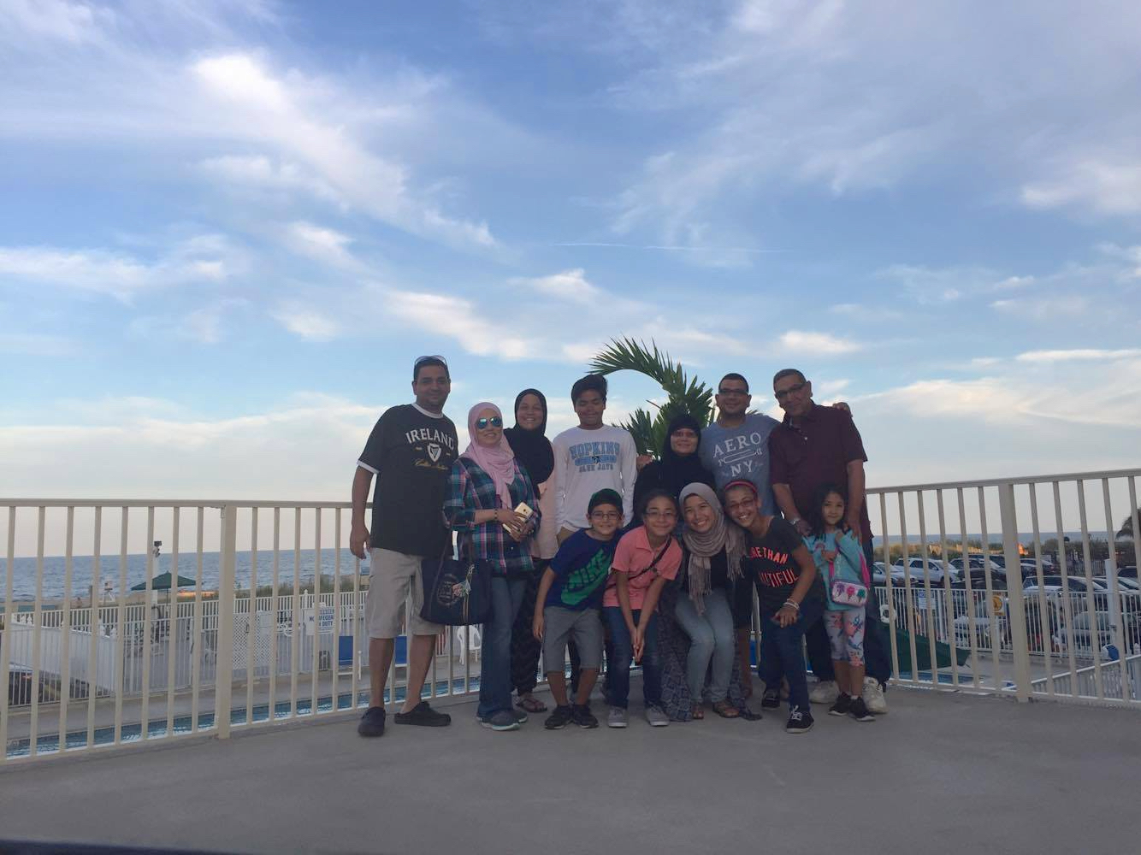

Last month, both Tamer and Nader went before a 10-person board of IBM’s technical leadership to make their case for why they deserved the title **Senior Technical Staff Member** – recognized across IBM as individuals with a clear and superior record of sustained technical achievement, innovation, and business impact who will continue contributing vigorously to IBM's growth. It’s a grueling process that requires nominees to prove out their qualifications through education, proven value to the business, sustained progress and recommendations from IBM executives.

Both met the board on the same day. Both heard from the Board on the same day.

Both received the STSM honor!

Tamer got the word first – and by lucky chance he was with his Hero – his chemistry teacher father. “He told me this is something you earned and you should be proud of, and you should share it with your kids so they understand the drive and the need to earn it. I taught you how to excel, you achieved your American dream, now pass it along to your children.”

Nader was with his daughter Noor, a sophomore at Johns Hopkins University when he got the news. After the elation of the news wore down, he voiced how much he wished his Mother could hear this – Mrs. Nassar passed away a few years earlier. “My daughter said to me, “she did get to see your success” which made me so proud. My mom wanted me to be a doctor, but I had a passion for math. I wanted to be an engineer and she understood and supported me. My mother passed on to me the will to drive, to never settle, always look at the next step – be ambitious. She was a born leader. I got that from her.”

So, what does being an STSM mean – and what’s next for this high-flying brothers? “It means that it is my responsibility to provide my expertise and experience across IBM now,” says Nader. “It’s an earned trust – trust that I can set expectations and provide leadership not just to my team but across IBM. voice is heard and my opinion matters”.

Tamer added, “It’s the highest technical non-executive role in IBM and both Nader and I are already working toward DE – and one day IBM Fellow. Those are our joint ambitions, and we know we are capable of it.”

Hero’s indeed.

# # #